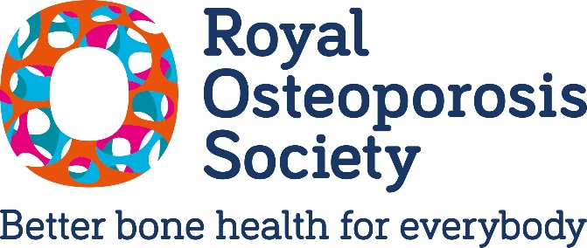
Thank you for taking the time to contact your MP about the rollout plan for Fracture Liaison Services.
How to use this template letter?
You can find our template letter on the next page of this document. Just replace the highlighted fields to personalise your letter/email. Please do change any of the wording to reflect your own personal style. Adding your address is particularly important as it lets your elected representative know you are a constituent.
Adding a brief personal story (for example, when you were diagnosed, how many (if any) fractures you have suffered or how osteoporosis has affected your daily life) can make a huge difference in showing why this matters right now.
How do I contact my MP?
You can find contact details for your MP here: https://members.parliament.uk/FindYourMP
What to do next?
As soon as you hear back - please share the response with us – you can send it to policy@theros.org.uk. Even a brief reply helps us demonstrate to Ministers that voters demand better osteoporosis care. Every response counts.

Dear [insert name of MP],
I’m writing – as your constituent – to ask for your help to make sure the Government’s pledge to beat osteoporosis will be implemented, so thousands of people’s lives can be changed and saved.
[Recommended space to add your story of osteoporosis - If you have osteoporosis, you could talk about when you received a diagnosis, whether you’ve experienced any fractures yourself, and any worries you have with the condition]
Osteoporosis is normally overlooked until it’s too late to prevent devastating broken bones (fractures). Half of women aged over 50 and one in five men will suffer fractures, often from something as minor as a trip, a stumble – even a hug or a cough. The result of undiagnosed osteoporosis can be devastating. A hip fracture is a 'heart attack-level' event – one in four people won't survive, and many more lose their independence.
But the good news is that there are safe, effective medications available, provided people get an early diagnosis.
Fracture Liaison Services (FLS) are early diagnosis services which give people the early access to medication they need. They break-even within two years through preventing fractures. But only half of NHS Trusts in England currently provide them.
Ahead of the last election, Wes Streeting promised to end this postcode lottery and to make commissioning a “roll-out plan” for FLS in every area one of his “first acts in post”. While it’s good to see this commitment repeated in the 10-Year Health Plan we still don’t have any detail on how this promise will be kept or when the life-saving work will start.
And delay costs lives. Without action, 2,500 people will continue to suffer preventable deaths from hip fractures every year – people whose lives these services could have saved. As someone living with osteoporosis, I want to see this pledge delivered so an early diagnosis becomes standard, and so the NHS no longer has to pay to put things right after fractures people should never have had to suffer in the first place.
Japan and New Zealand have covered everyone with these services and it’s important the Government delivers its pledge to do the same here.
Please can you use your influence to write to or have a conversation with Mr Streeting or his Ministers to ask that he now publishes his plan and starts work this year, so we can save the maximum number of lives.
Thank you for your time, and I look forward to your response.
Yours sincerely,
Your name
Your address

