Research Grants Programme Application Overview

Grant Administration
The Royal Osteoporosis Society is committed to continually improving its grant administration process by: Reviewing the application and peer review procedures; Setting in place monitoring and evaluation systems; Establishing appropriate financial controls; and Reviewing the legal and regulatory environment. This document gives an overview of how the grant process is conducted.

Call for Applications
Research Grant Rounds are advertised at the charity’s conference when timescales are appropriate. They are also publicised through Osteoporosis Review and the charity’s website. Additional links will be provided through other appropriate websites, such as those of other professional bodies. The specific awards available during a particular grant round will always be clearly advertised.

Peer Review Process
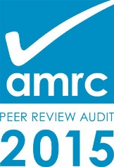
Before funds are committed to research projects, a two-stage rigorous process is followed to ensure that the research which is funded is of the highest standard (Figure 1). National and international experts in the field are asked to comment upon research proposals. The expert comments are taken into consideration when judging the overall quality and relevance of a piece of research to the charity’s Research Strategy and Research Roadmap. Only after this process has been satisfactorily completed does the Board of Trustees approve funding for any research project. This process is called peer review and is guided by principles set out by the Association of Medical Research Charities (AMRC). The charity currently holds a certificate in ‘Best Practice in Medical and Health Research Peer Review’.

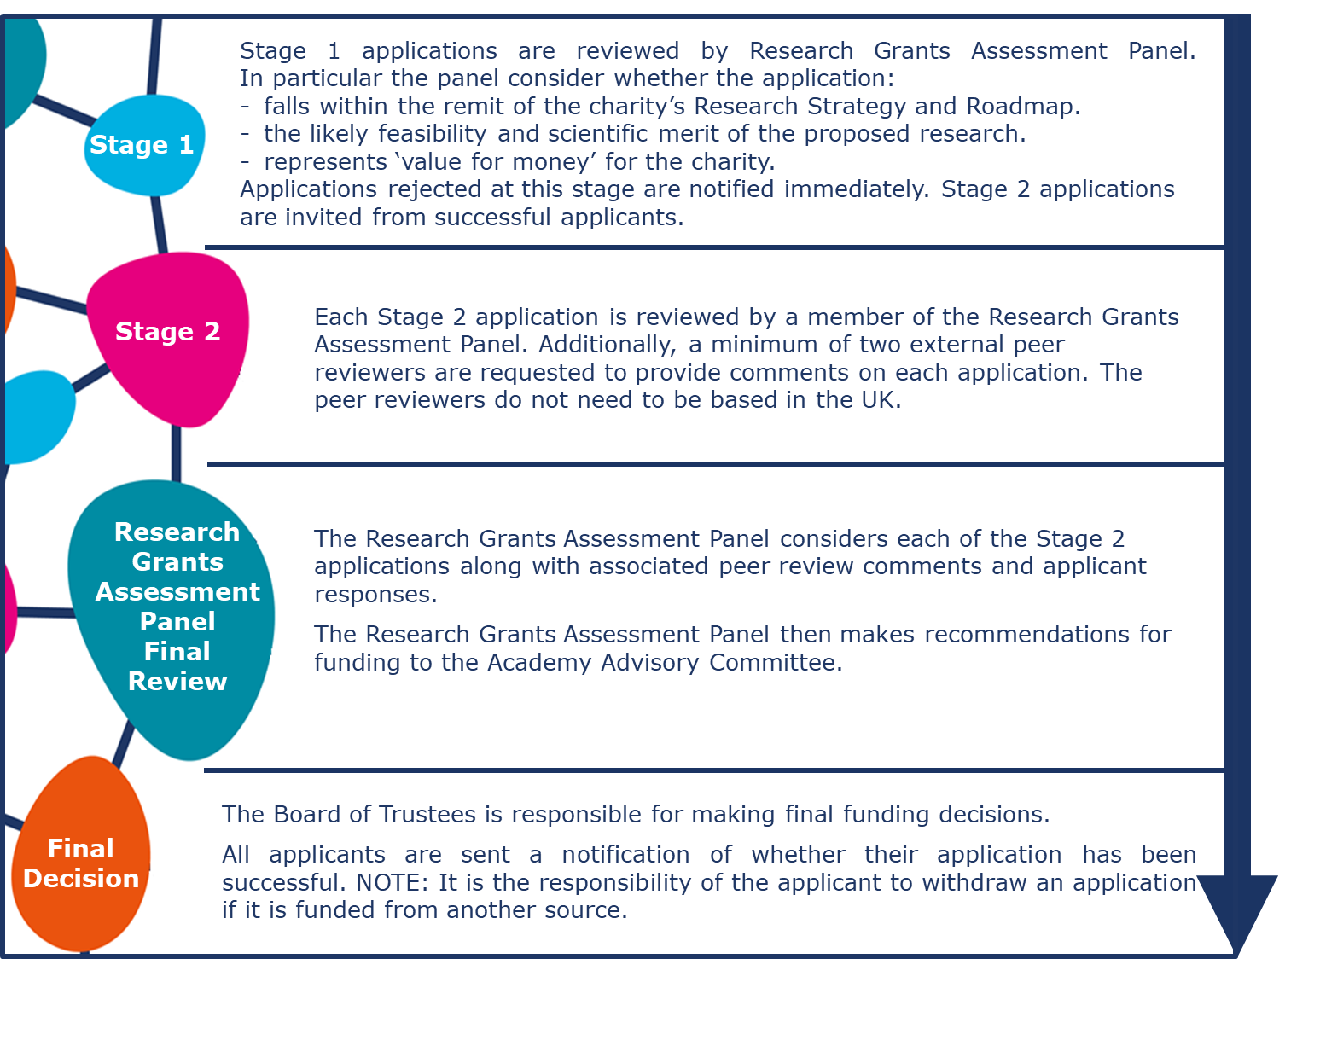
Figure 1: Royal Osteoporosis Society Research Grants Peer Review Process

